Client Requests
  - The client has requested several things directly; these are urgent changes that must be completed first.

The client has requested that the DMS page contain more columns
- Sold by – this column should list who sold the vehicle
- Sold to – this column should list the customer who bought the vehicle
- Date sold – this column should list the day the vehicle was sold
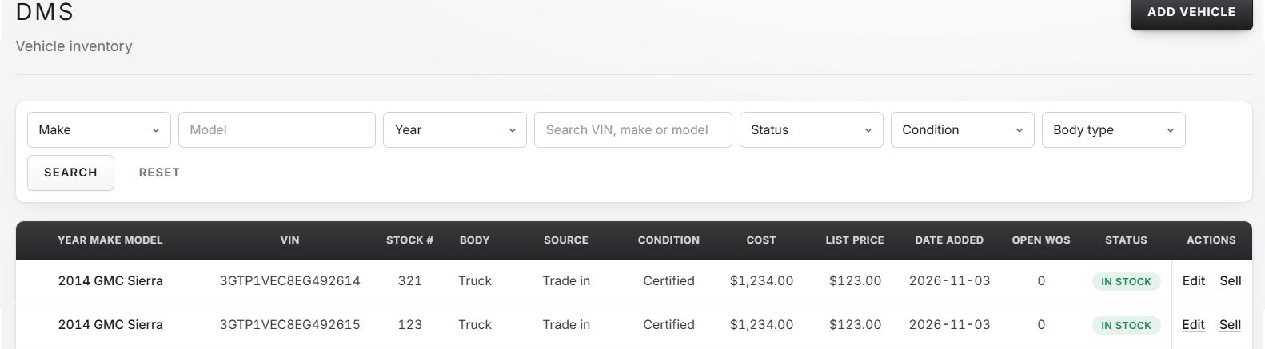
Where columns should go

When the sell vehicle action is clicked, the client has asked that more information be presented in that menu. The client wants the following added; cost, total number spend on work orders, and list price.
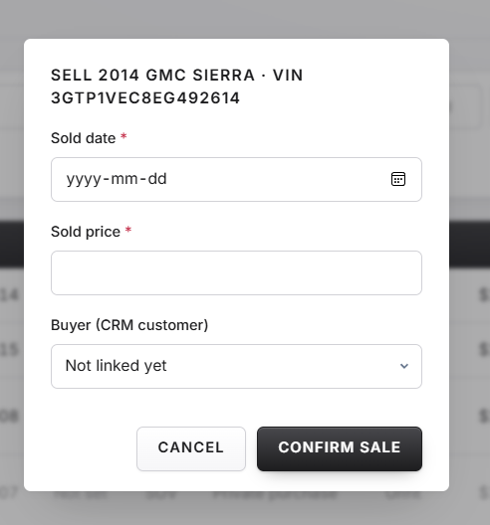 Menu in reference
The client has requested that the sales report page contain more information.
The client would like to be able to see sales information for the current day, week, month, year and have each listed as options, the client would also like to see this in the sales section of the dashboard. The client would also like a list of all sales employees and their sales metrics.
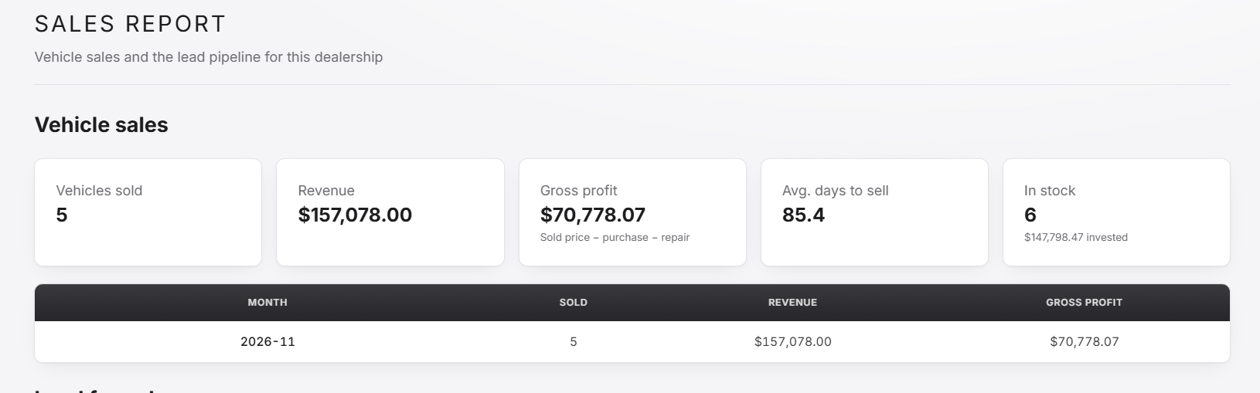
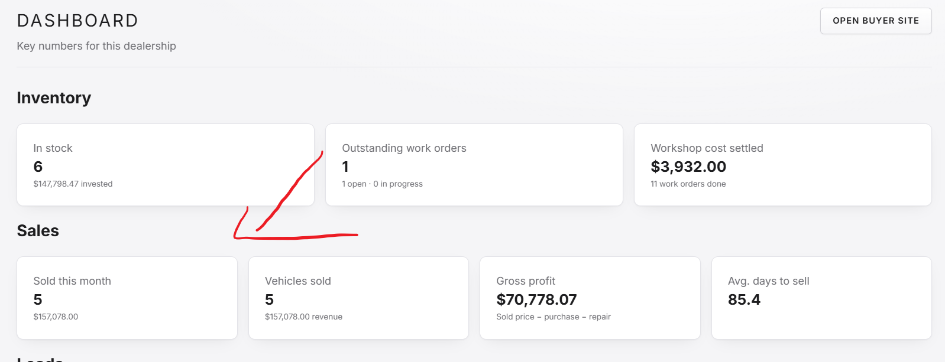

The client has requested that manager accounts be allowed to promote other staff to managers, as well as being able to edit certain employee information. The client has also requested a column in the members section listing when the member joined
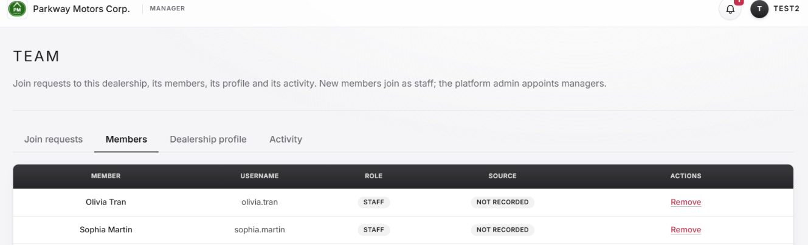
The client has requested that the create account functionality on the home page be converted into a way for dealerships wanting to inquire and potentially use the service
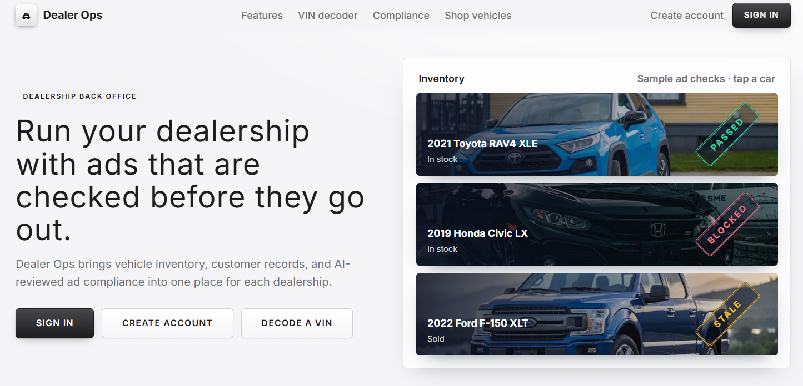
The client talked about account creation being done a different way; however, this is something we need to discuss further with the client. For now, removing the button to create account from the home page will suffice.

What was also discussed with the client was the potentiality of a dealership specific admin/owner/regional manger account that has some admin capabilities to change things with the dealership, like the platform admin account, but is exclusive to a single dealership. This functionality is optional and should likely be discussed further with the client before full implementation occurs.

From most to least privilege:
Platform admin
Dealership admin/owner/regional manager
Dealership manager
Dealership staff
User not logged in
The client mentioned specific columns being sortable on the DMS page, on top of those ones I have highlighted several other places where columns should be sortable in the screenshots below, if you feel any other columns that I haven’t listed should be sortable feel free to add that functionality.
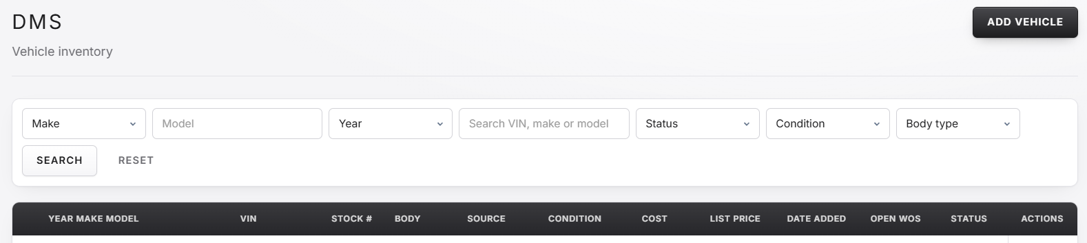
When logged in as any user account > DMS
Sortable Columns: Stock#, Body, Source, Condition, Cost, List Price, Date Added, Open WOS, Status

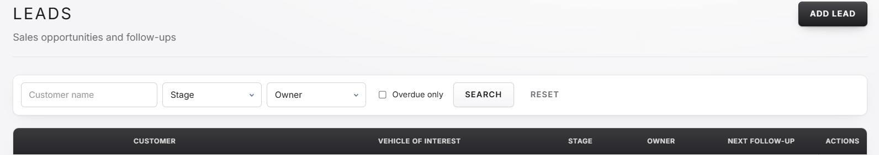
When logged in as any user account > Leads
Sortable Columns: All
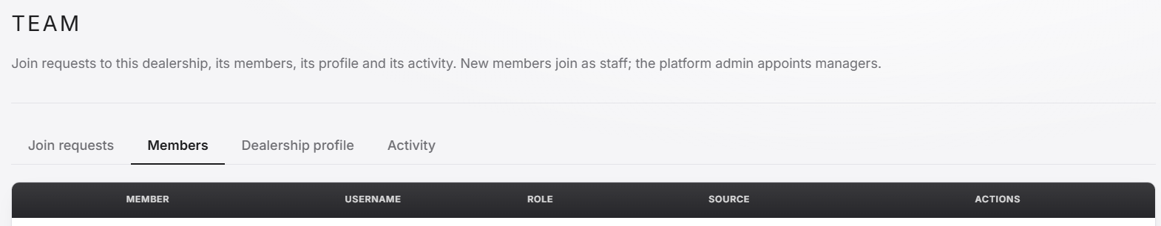
When logged in as any user account > Team > Members
Sortable Columns: Role, Source, Date Added (when added)
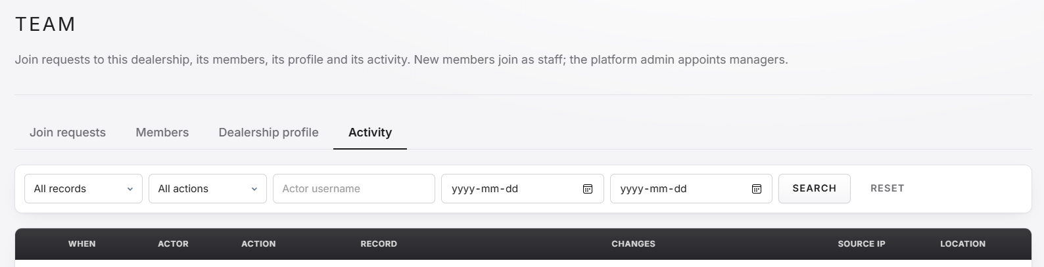
When logged in as any user account > Team > Activity
Sortable Columns: When, Actor, Action, Record (type followed by number), Source IP, Location
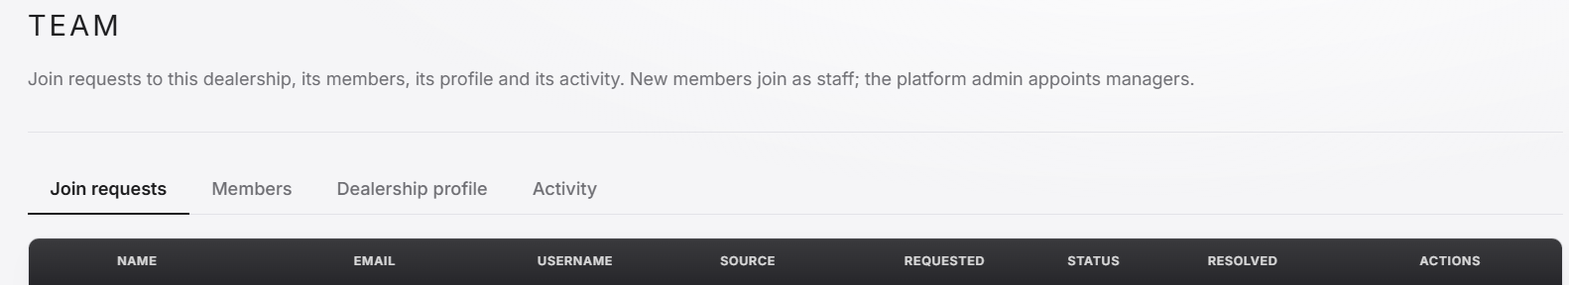
When logged in as any user account > Team > Join Requests
Sortable Columns: Requested, Status, Resolved
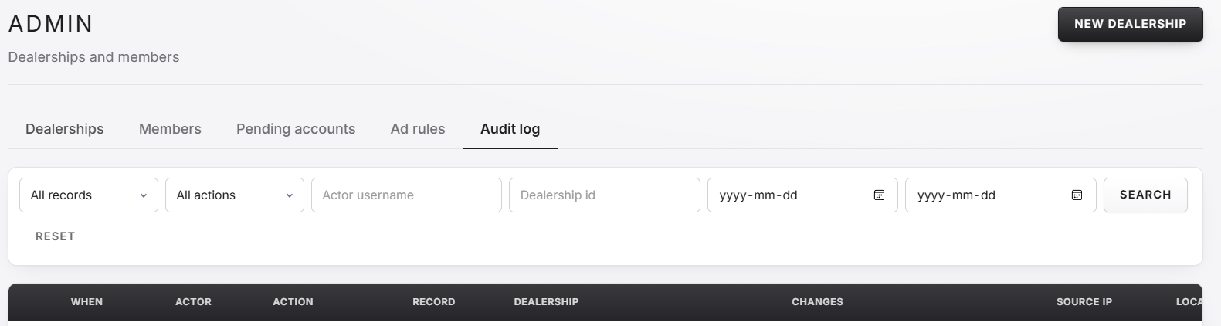
When logged in as platform admin > Audit log
Sortable Columns: When, Actor, Action, Record (type followed by number), Location
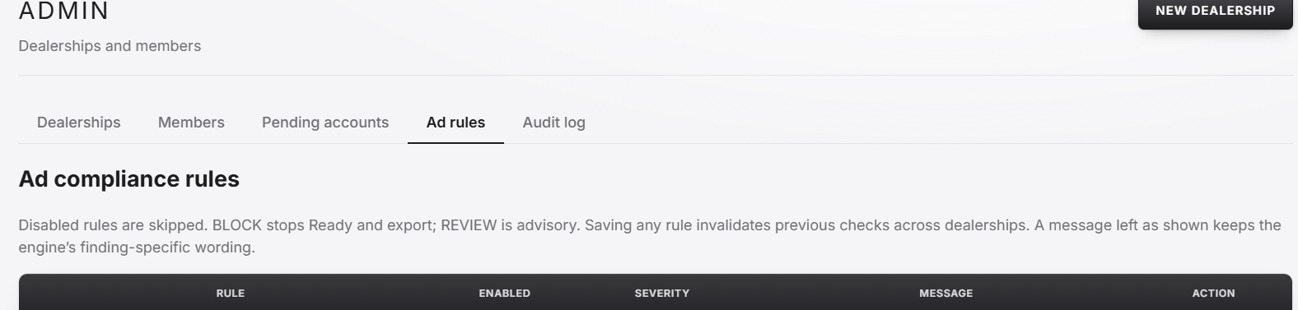
When logged in as platform admin > Ad Rules
Sortable Columns: Enabled, Severity
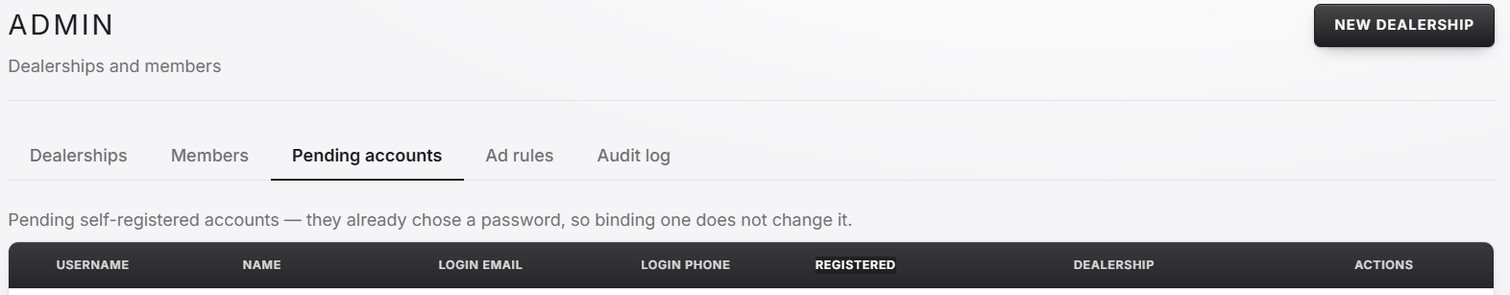
When logged in as platform admin > Pending accounts
Sortable Columns: Registered
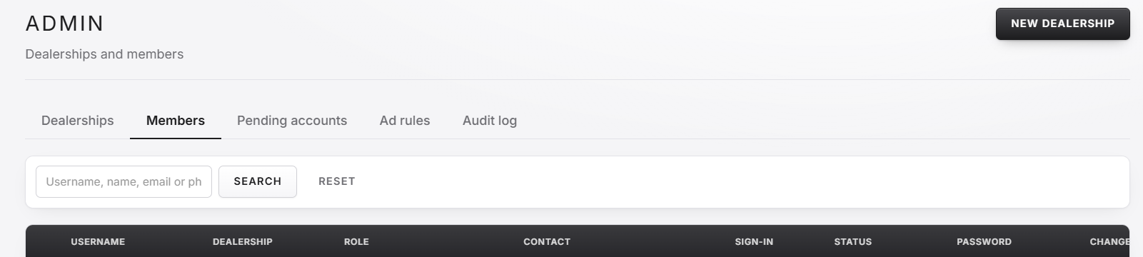
When logged in as platform admin > Members
Sortable Columns: Dealership, Role, Sign-in, Status
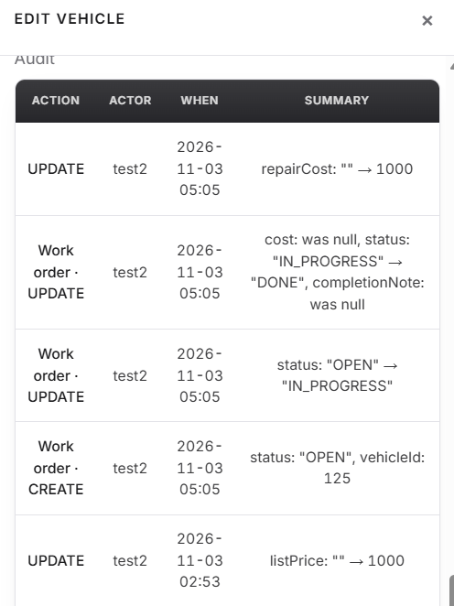
When logged in as manager account > Any menu with audit
Sortable Columns: Action, Actor, When

Site Fixes and Changes
  - These are issues that have been located with the site and things I believe should be changed, they are less urgent than the client requests but should still be implemented, especially the fixes.

FIX: Currently an account is unable to be created if the full name is already used. Many people have the same name and would be unable to have an account with the current system. I have found three places where this occurs but there may be more.
On home page, clicking any of the create account options
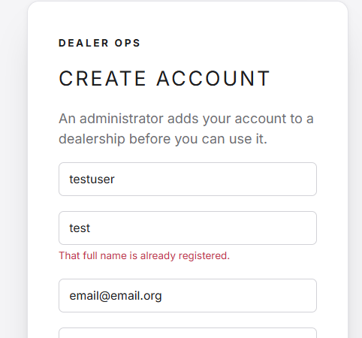
Logged in as platform admin > Dealerships > Staff > Create new staff account 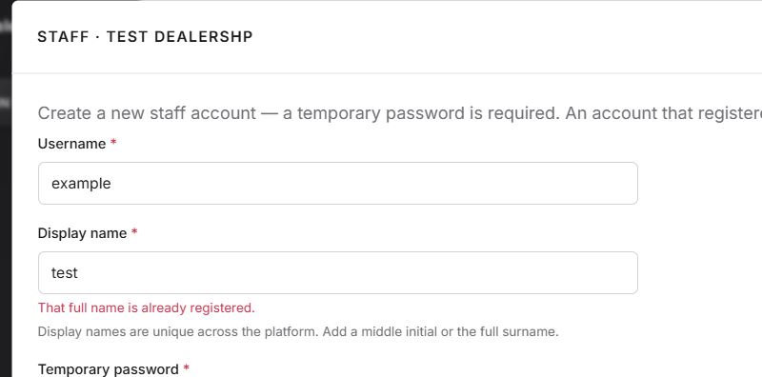

Logged in as any account > Profile
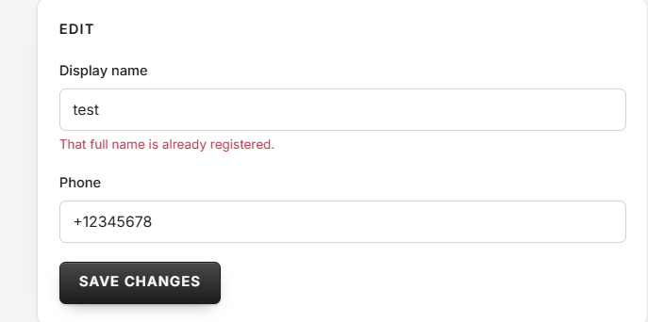

Fix: Many menus give no confirmation when there is unsaved data or when changes are made, this can cause many issues such as, accidental changes, loss of data, frustration, … screenshots

Logged in as platform admin > Dealerships > Edit
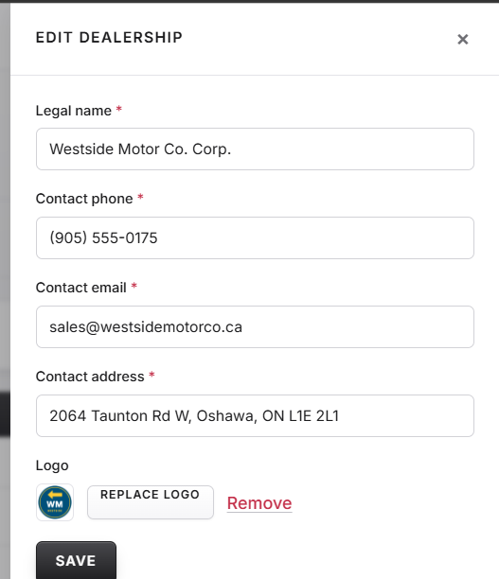

Logged in as any user account > DMS > Add vehicle + Edit
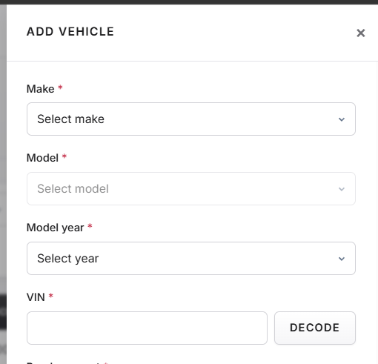
Logged in as any user account > CRM > Add customer + Edit
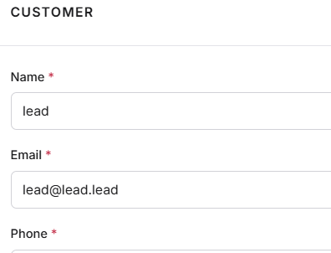
Logged in as any user account > Leads > Add lead + Edit
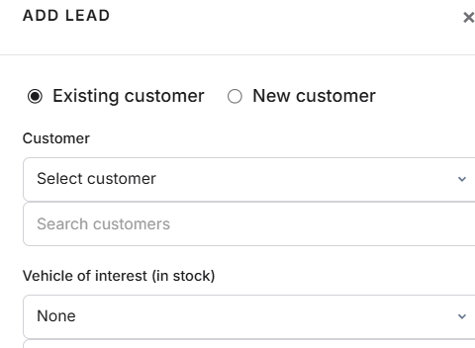
Logged in as manager account > Team > Dealership profile
A larger change like this should require a confirmation before it is saved.
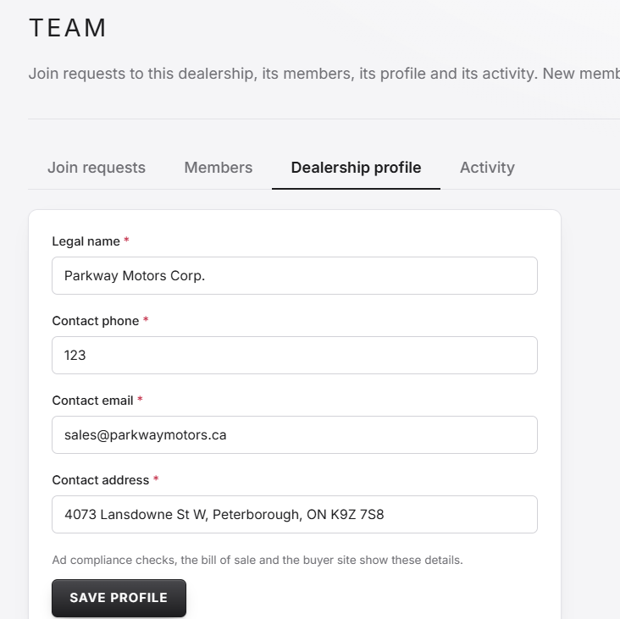
Logged in as any user account > Leads > Open
When closing a lead, confirm before saving
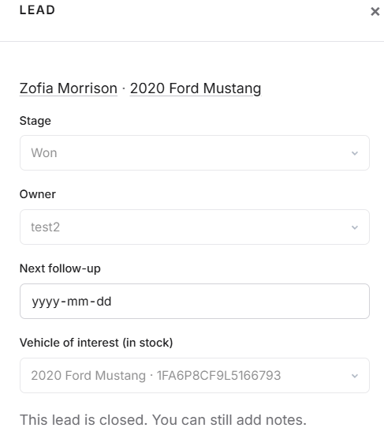

Change: Currently join requests lists every single request, I feel this should be split into to tables, one for current requests that need to be approved or rejected and one for all past requests that have been approved or rejected.
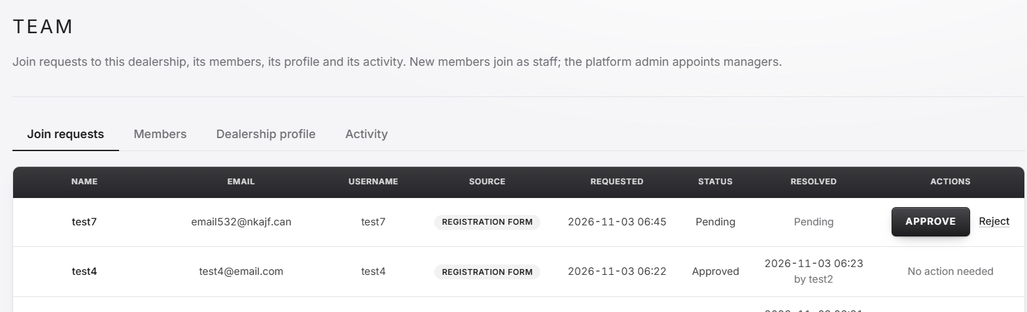
Logged in as any manager account > Team > Join requests
Change: The day pickers in the team activity page are unlabelled, and it may be difficult for a user to figure out their functionality. Additionally there are day pickers in the admin audit log that should also be changed accordingly.
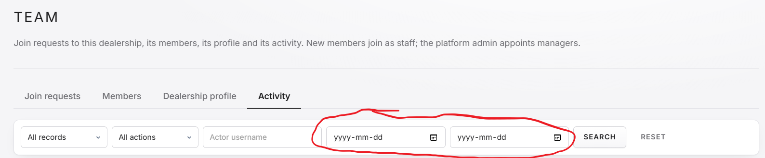
Change: There should be a way to search the activity log based on the change made, such as searching the word “password” to find all login requests made with passwords
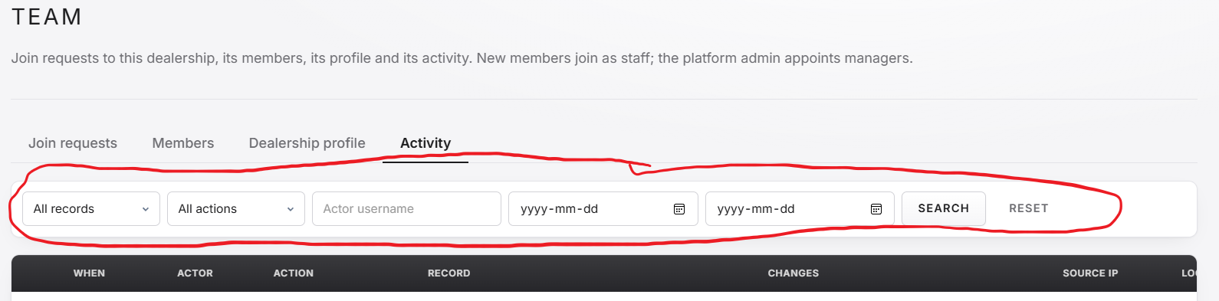
Change: The search options and columns should be in the same order to improve the look of the page.
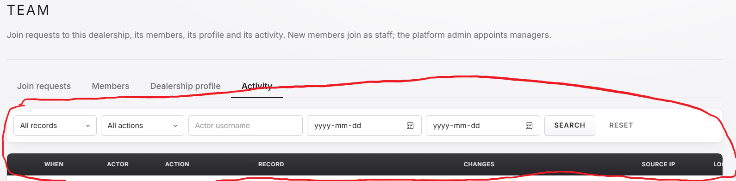
Logged in as any manager account > Team > Activity
Change: Many search options are redundant, lack certain functionality, are confusing or should be changed in a different way. Below I have listed all boxes I’ve found that need adjustment and the suggested change. This may not be all the boxes needing changes.

The “Make” and “Model” Boxes in DMS are redundant as the “Search VIN, make, or model” provides the same functionality in a better format. I suggest the “Make” and “Model” boxes be removed.
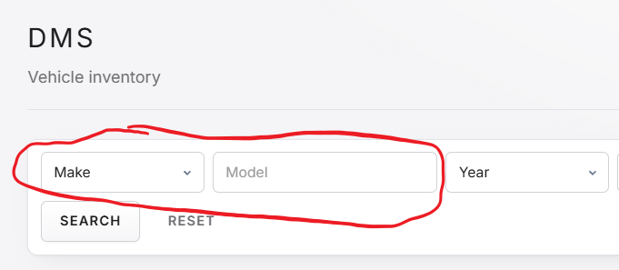
The “Year” box in DMS is difficult to use as there are many years listed. I suggest that this box be turned into a typeable box.
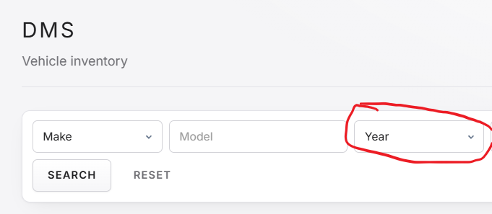
Additionally, I suggest adding a box to be able to search based on Stock #
The “Add Vehicle” drop down menu is difficult to use because of its size, I suggest splitting the drop down into two sections, one listing major brands and one listing every brand. Similar to that seen on Autotrader (see screenshots).
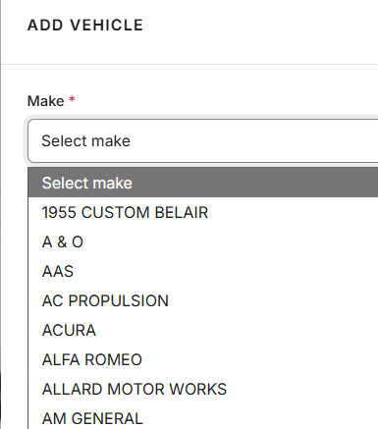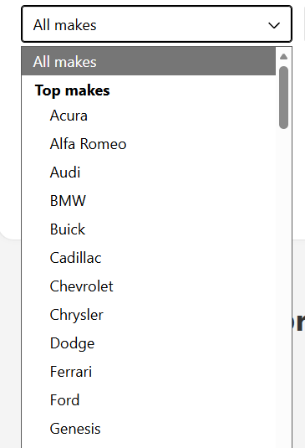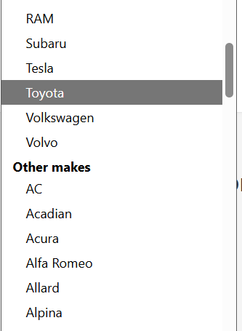
Dealer-ops Autotrader Autotrader

The “model Year” drop down menu is difficult to use because of its size. If possible, I suggest only listing model years that the selected vehicle can be used with. If this is too hard to implement for every vehicle I suggest only implementing it for common vehicles.
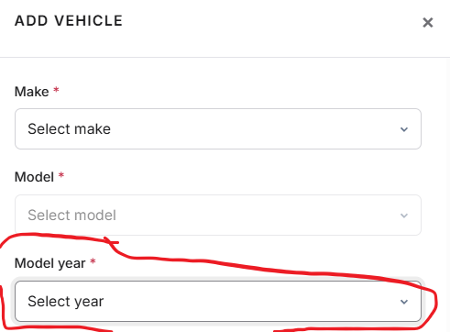

Additionally, I suggest that the VIN box should be moved to the top. I would also suggest that a box be created to search for vehicles with open work orders

The “Customer” and “Vehicle of interest” boxes are confusing and difficult to use, I suggest making the boxes similar to that seen in the leads menu (see screenshot).
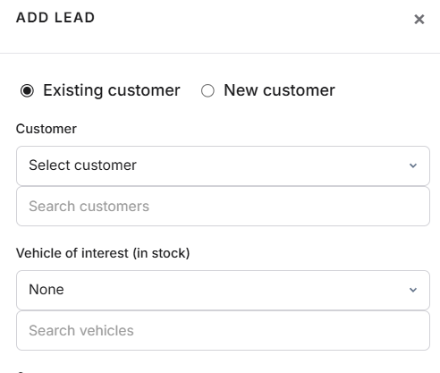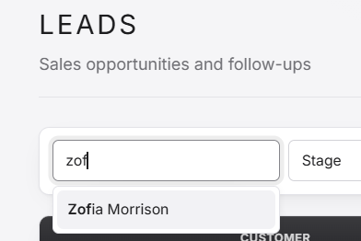

When searching team activity by users results are not shown on partial searches, I suggest searches being able to work with partial searches
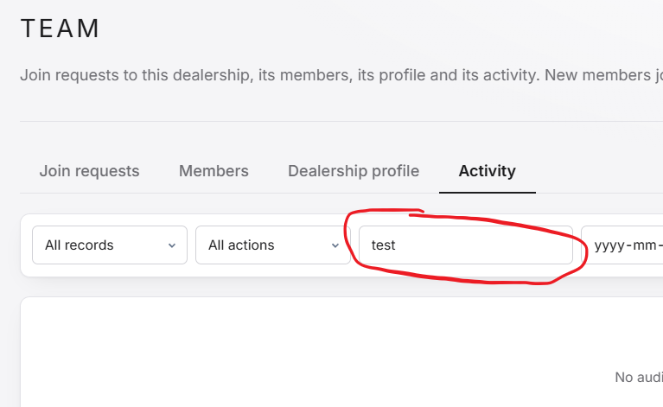

In the leads page, I suggest that the owner field be already filled in, but changeable, to the individual creating a lead.
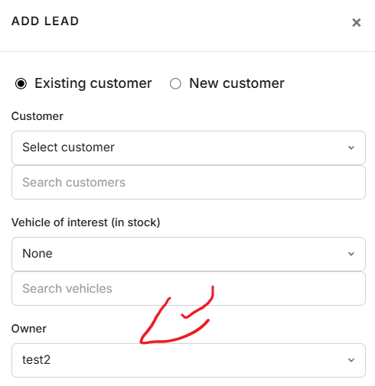
Additionally, I suggest that a search box be added for vehicle name. I also suggest that when a name is typed into the “customer name” box the list should auto update, similar to the DMS and CRM pages.
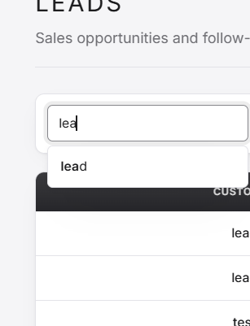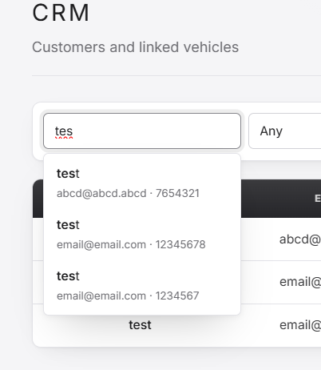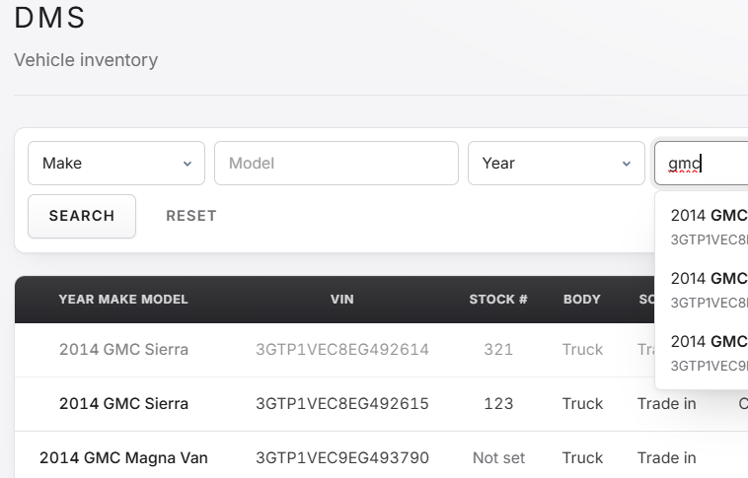

Change: There should be a way to reopen leads that are closed, this can be useful in the case of something like an accidental closure.

Changes: The vehicles purchased column in CRM feels unnecessary as many people will only purchase a handful of vehicles in their life, so being able to see how many they have bought is not as useful information. I would suggest replacing this with the leads for the customer.
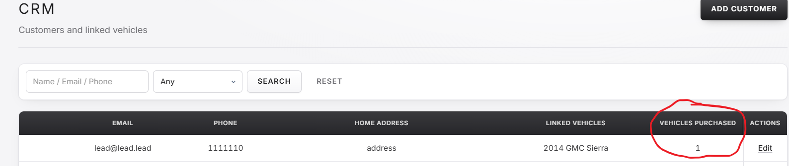
Logged in as any user account > CRM

Changes: Being able to add a lead inside of the customer menu would provide extra functionality and usefulness
.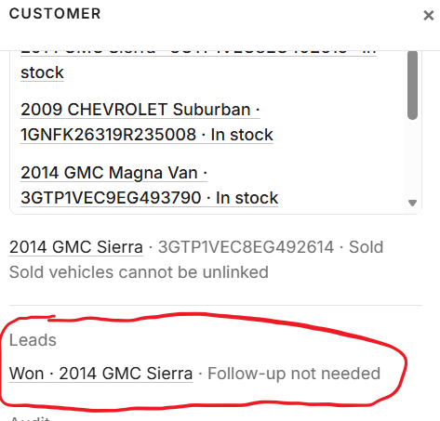
Changes: There should be a way to add notes about customers in the customer menu
Changes: When creating a new customer if the name, email, phone, or address are the same, I suggest that a notification pop up saying something similar to “a customer with this name/email/phone/address (based on what it is) already exists, are you sure you would like to create a new customer” before allowing creation. Additionally, phone numbers are exclusive for customers, I feel they shouldn’t be as some people share a phone number and may want separate customer profile. This both in the regular customer creation and customer creation through the leads page
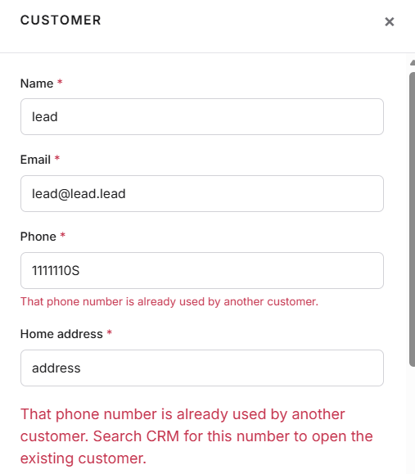
Logged in as any user account > CRM > Add customer + Edit
Changes: VINs should be forced to match vehicle information in DMS page
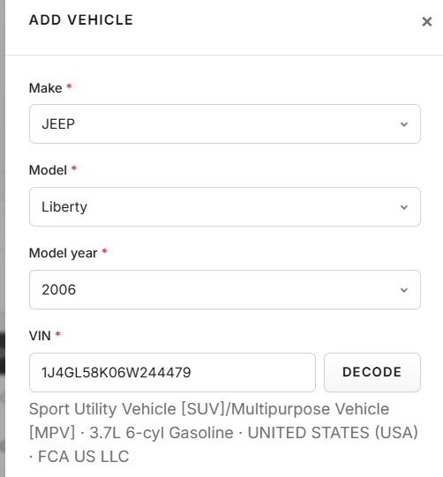
Changes: I suggest that the “Carfax URL” box in DMS should be exclusive and require an actual Carfax link before the information is saved.
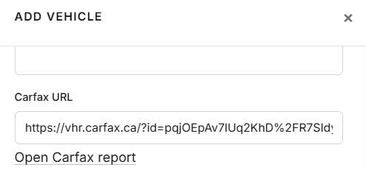
Changes: When selling a vehicle, I suggest that the vehicle sale is required to link to a customer before it can be sold, with the option to pick “other” and manually type in a buyer.
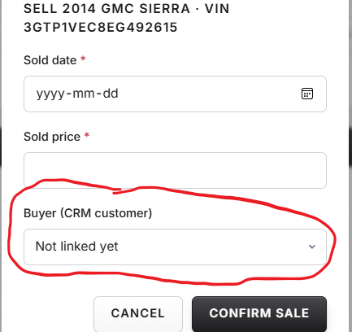
Changes: I suggest that leads be added to vehicle information in DMS, with the possible addition of a column for the amount of leads a vehicle has this would help unify the systems available for the site.
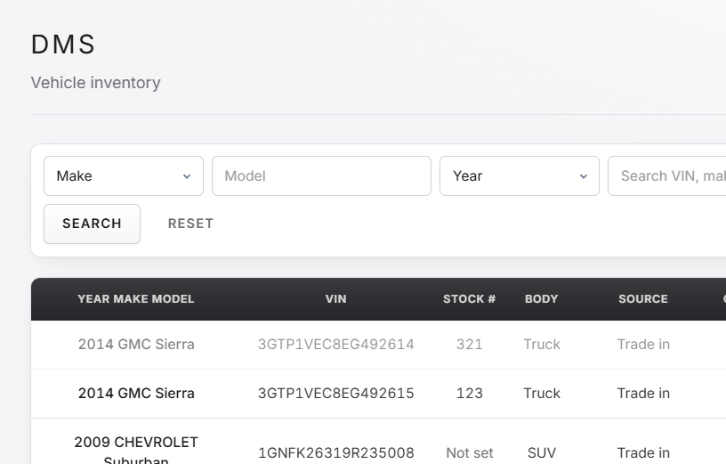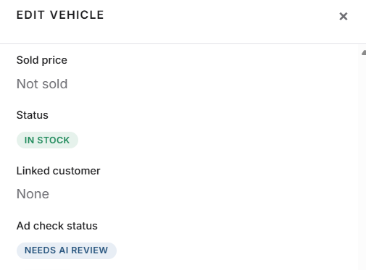

Changes: Duplicate leads, with the same customer and vehicle, should not be able to be created, in order to avoid redundancy.
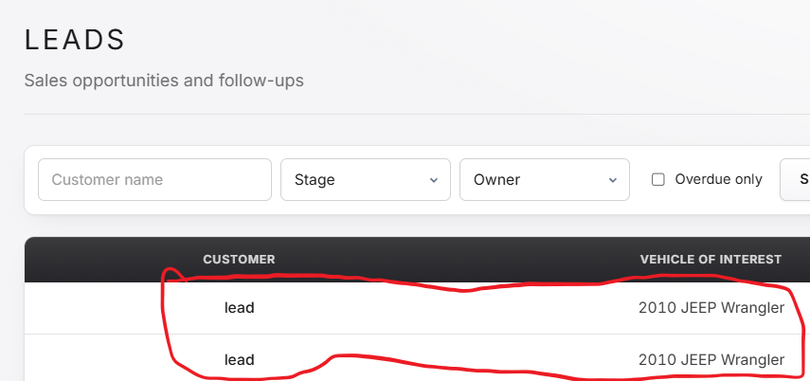

Changes: Leads should be tied to vehicle sales. When a vehicle is sold to a customer, they should be automatically closed with the appropriate label applied to the customers tied to the lead. This will increase integration between the systems of the site.
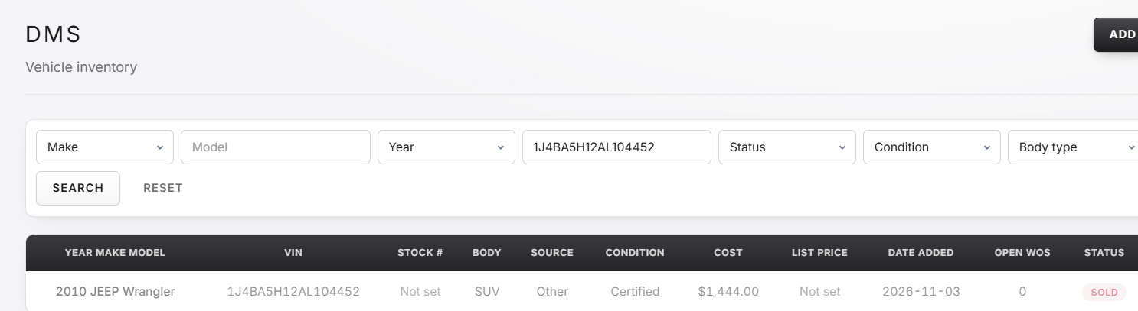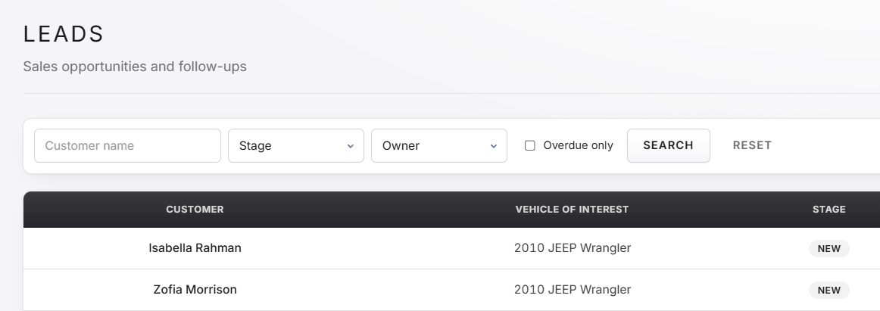

Fix: Display name should be listed as full name in Profile and when creating a staff account through the admin page
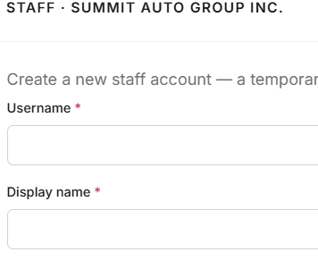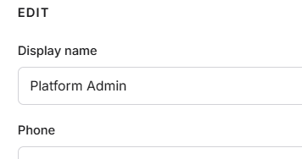

Fix: When creating a staff account for a dealership, typing the username with incorrect characters returns a difficult to read error.
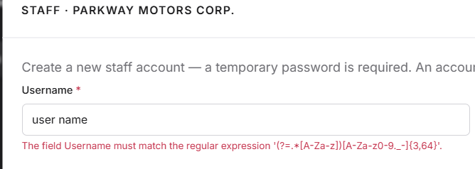
Logged in as platform admin > Dealerships > Staff

Changes: The platform admin should not be able to directly bind accounts to dealerships, instead they should only be able to send the join request to the dealerships. This will improve security and prevent a platform admin from being able to create an account to go and access a dealerships customer and vehicle database, something the client asked platform admins to not be able to do.
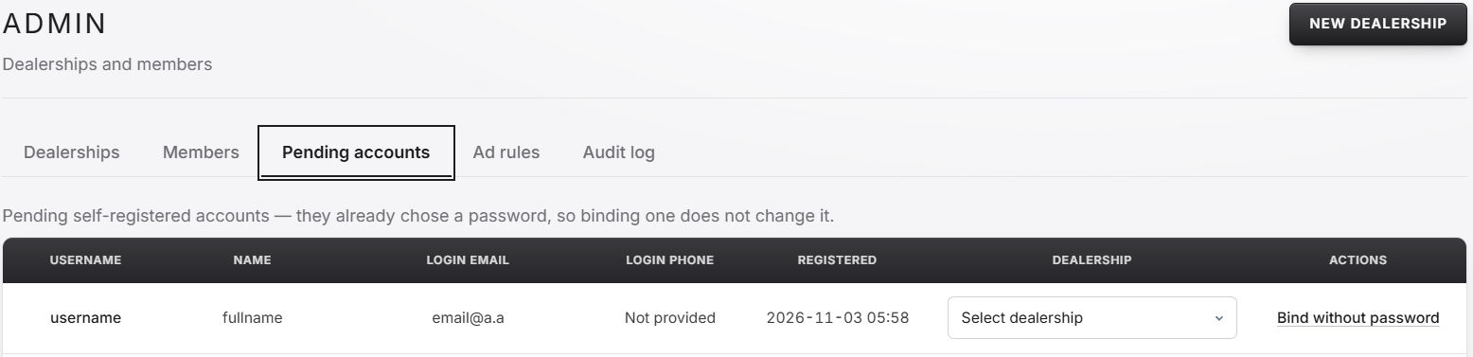
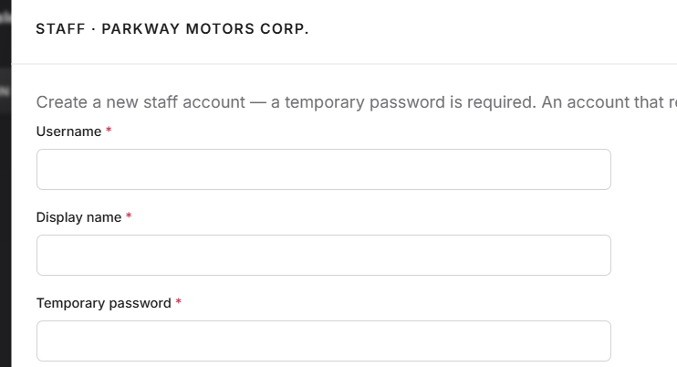
Changes: Admins should be able to remove pending accounts
Changes: Pending accounts should be able to be edited in some way by admin, such as email, phone, username, in the event that account creation information was accidentally input incorrectly.
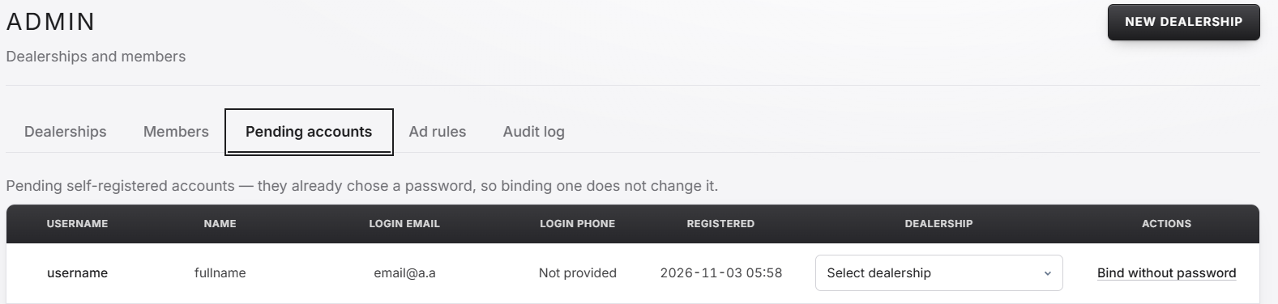
Logged in as platform admin > pending accounts
Changes: Admin audit log should have search options and columns should be in the same order. Additionally admin should also be able to search based on changes.
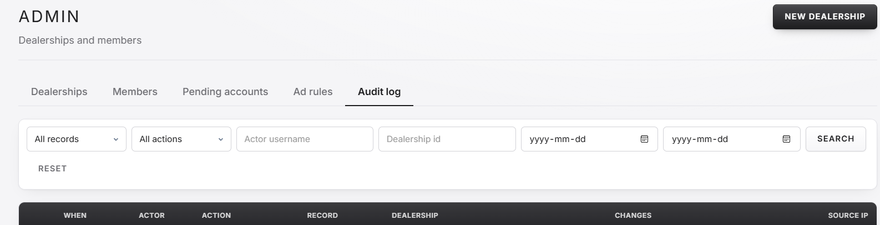
Changes: Searches in admin audit log should return results when partial searches are entered. Additionally, as mentioned earlier the day picker boxes are unlabeled.
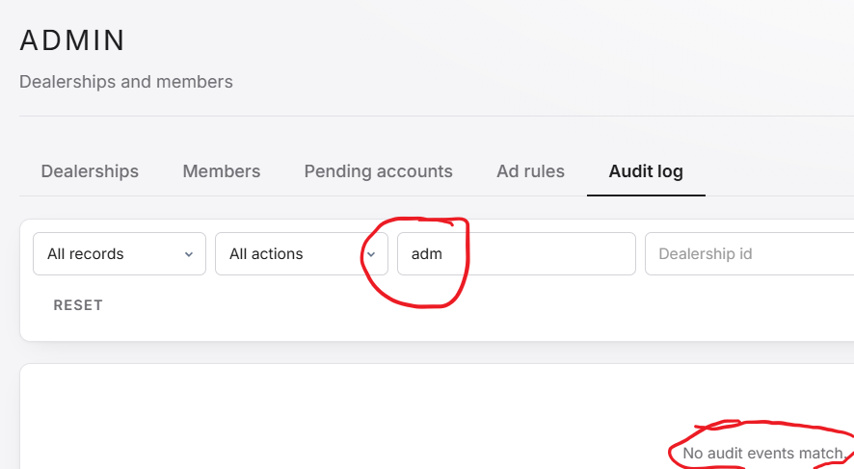

Changes: Dealerships should be able to be deleted by platform admin; however, this should be a more complex decision requiring at least one extra step to confirm.
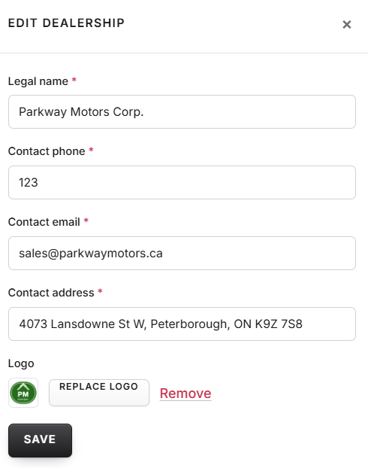
Logged in as platform admin > Dealerships > Edit
Changes: Admins should be able to delete users; however, this should be a more complex decision requiring at least one extra step to confirm. Additionally, admin should be able to edit some information on accounts, such as email or phone number.
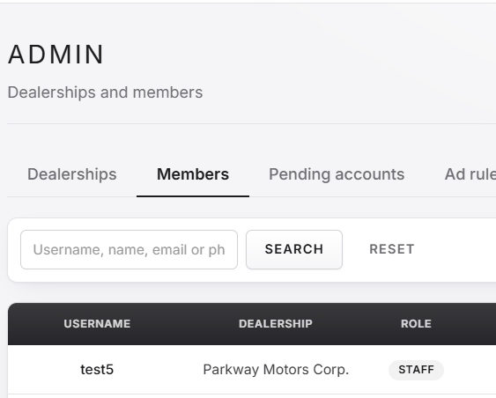
Changes: The sample ads on the home page link to the sign in page. I believe most people who are clicking on the ads are potential users and this should link to the sign-up page.
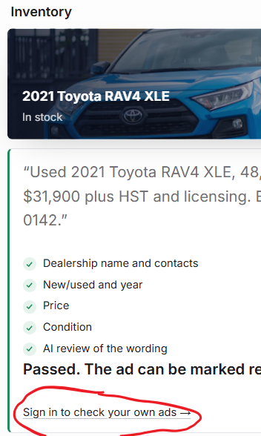
Home page

Changes: I feel like there should be something bigger on the home page saying that that page is for dealerships and not customers.
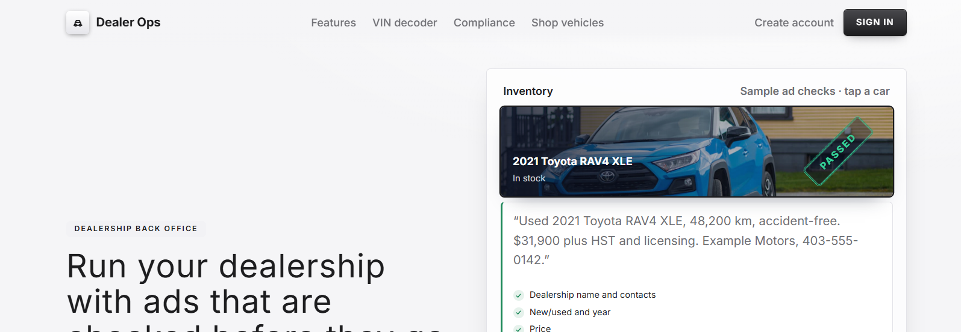
Home page

Changes: The dealership shop page shouldn’t say “used” as many dealerships hold and sell new vehicles.
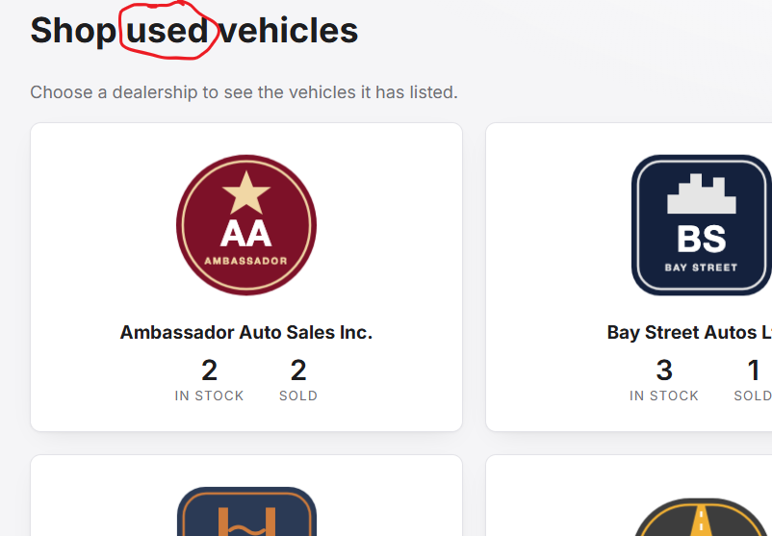
Home page > shop vehicles
Changes: I suggest that there should be a way to search for dealerships on the dealership shop page. Additionally, I believe it would be good to list dealerships address and some contact information on each of the dealerships on the page
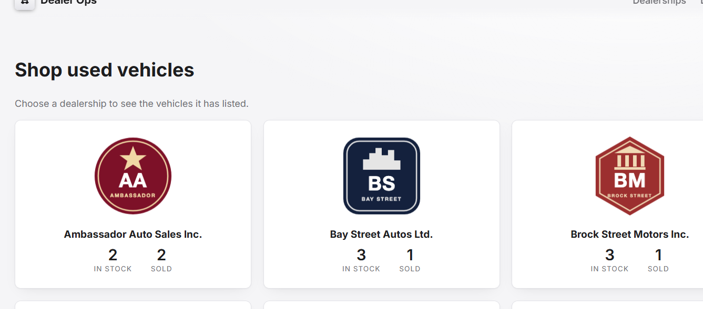
Home page > shop vehicles

Changes: There should be a back button in the dealership buyer site. Additionally there should be a way to search a dealerships inventory for a specific vehicl
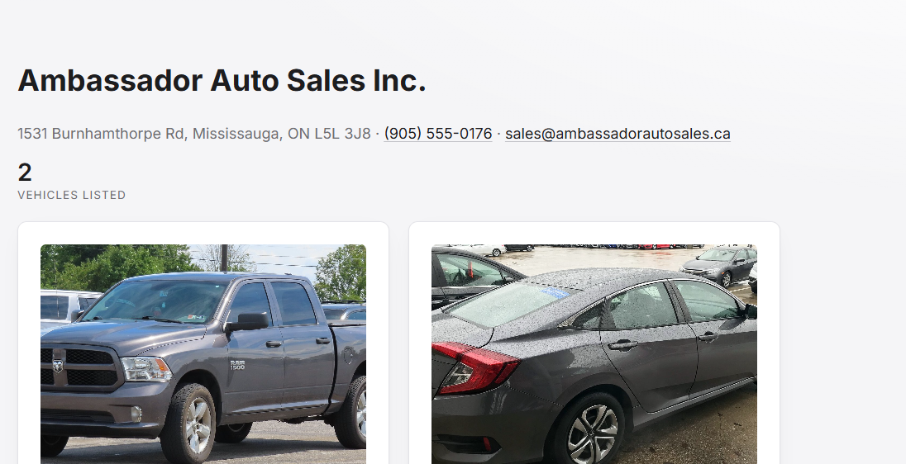
Home page > shop vehicles > click any dealership
Changes: When asking about a vehicle, the character limit should be visible when it becomes closer.
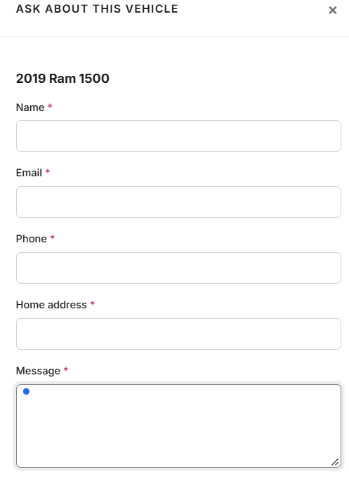
Home page > Shop vehicles > click on any dealership > Ask about this vehicle

